**GROUP 6**

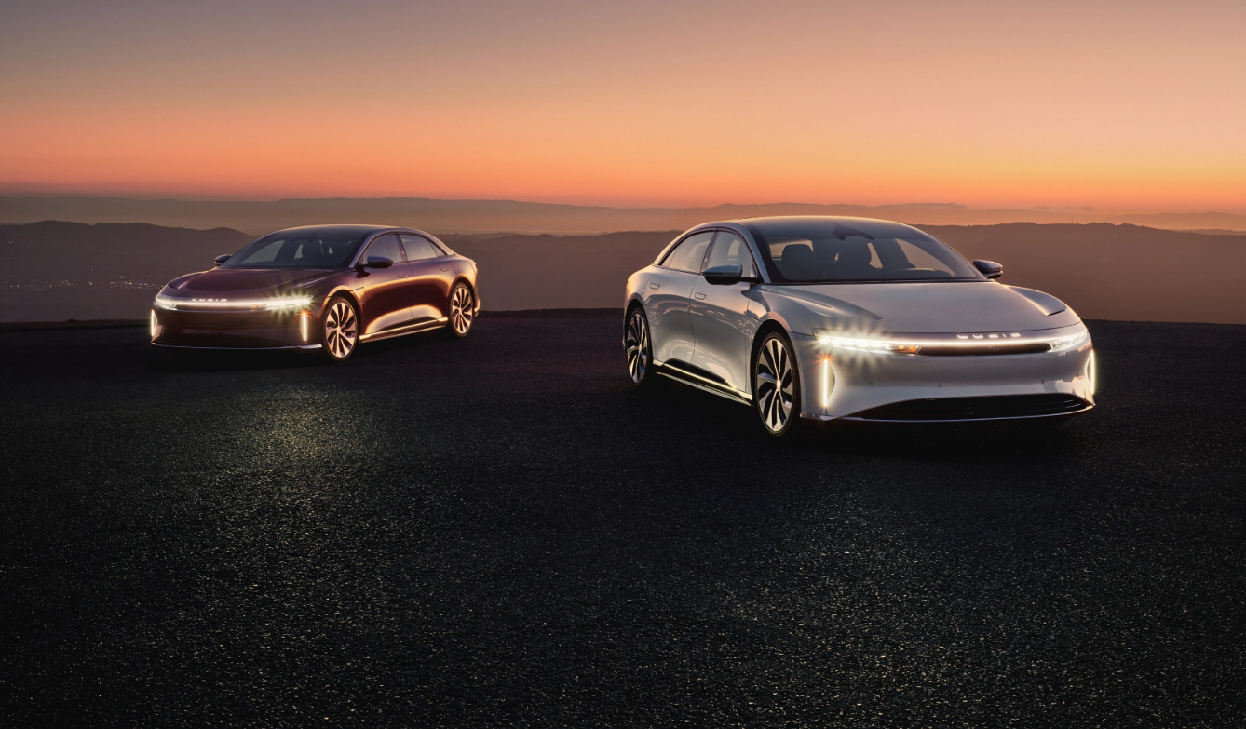

**PROG8060 – DEVELOPING QUALITY APPLICATIONS**

**REQUIREMENTS AND SPECIFICATIONS**

**FOR**

**CAR DEALERSHIP BOT**

**Date: 03-02-2023**

**Group Members**

**Vanmathi Subramanian - 8879682**

**Preethi Manjuvanda Ganesh - 8825486**

**Tuney Mathew - 8848045**

**Anshu Abraham – 8756283**

1. **Purpose**

The purpose of this document is to gather all the requirements necessary to build a car dealership chatbot which will allow new customers to order a car / fetch details about car features so that the customer service rep do not have to be on the phone all the time.

1. **Overall Description**
   1. **Product Perspectives**

* This chatbot helps customers to place an order without being physically present in the showroom, hence reduce the time customers spend waiting in line.
* It helps sales representative by engaging with customers 24/7 and thus increasing the lead generations.
  1. **Product Features**
* This chatbot allows users to communicate with sales rep to book an appointment for consultation and test drive with minimal typing.
* It allows sales rep to engage with customers 24/7.
  1. **User Roles and Characteristics**
* **User / Customer:** who can chat with sales rep for booking an appointment, schedule test drive, get information about car delivery and about used cars.
* **Sales Rep:** who will engage with customer queries and concerns by chatting with the users.
  1. **Operating Environments**
* **Phone/Laptop:** The customer would need a phone to use the chatbot so that they can chat with the sales rep.
* **Store:** The car dealership store where the chatbot can run in order to engage with customers.
  1. **Constraints**

The chatbots cannot understand human context and it might lead to an angry customer.

* 1. **Assumptions**

By using car dealership chatbot, sales rep don’t have to talk over the phone and customers can easily get appointments by chatting with sale rep.

* 1. **Risks**

Car dealership chatbot might pose threats like spoofing, tampering of data and data theft.

* 1. **Dependencies**

The showroom needs to buy screen to run the chatbot and customers need a smartphone/laptop/desktop to use the chatbot.

**3. System Features**

**3.1** Ability to book an appointment for consultation.

**3.1.1** As a user, I want to book an appointment so that I can get an appointment agreement for a consultation appointment easily by just chatting with sales rep.

**3.2** Schedule test drives

**3.2.1** As a user, I want to schedule a test drive so that it becomes easier and hassle-free for users to schedule a test drive without any waiting time.

**3.2.2** As a user, I want to change booking so that I can update the convenient date and time of the scheduled test drive.

**3.3** Information about car delivery

**3.3.1** As a user, I want to get information about car delivery so that the user can exactly know when the car will be delivered to them.

**4 External Interface Requirements**

The chatbot should have access to a website's message platform for communication with users.

Database Integration: The chatbot must have access to and be able to retrieve data from the dealership's pricing and inventory systems.

CRM Integration: The chatbot must be able to connect to customer relationship management software to offer more sophisticated functions, including organizing test drives or service appointments.

Secured access: The chatbot must be able to safeguard the user's personal information and prevent unauthorized access to the chatbot's internal data.

**5. Non-functional requirements**

1. **Data encryption:** To prevent illegal access, the chatbot should be able to encrypt consumer data.

2. **Authentication**: To prevent unwanted access to the chatbot and its internal data, the chatbot should be able to authenticate users.

3. **Compliance**: The chatbot must adhere to all applicable privacy and data protection laws.

**Non-functional requirements for a chatbot for a car dealership may include the following in terms of software quality:**

1. **Scalability**: The chatbot must be able to accommodate an expanding user and data load without experiencing performance degradation.

2. **Usability**: The chatbot's user interface should be simple and straightforward, making it simple for customers to use and comprehend.

**6. References Used**

Messenger People (2022)

<https://www.messengerpeople.com/lucky-the-chatbot-fot-car-dealers/>